**A**

**M I N I P R O J E C T R E P O R T**

**On**

**“NAVIZIT : SMART CITY GUIDE”**

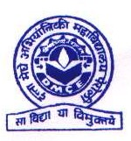

**DNYANESH SHARAD KHANDEKAR(TE-IT-A-56)**

**OMKAR SOMA LANDE(TE-IT-A-66)**

**PRATIK DILIP KHODKA(TE-IT-A-59)**

**SAHIL RAJENDRA PAGARE(TE-IT-B-16)**

Under the guidance of

**Mrs. Urmila Darekar**

Department of Information Technology

DattaMeghe College of Engineering,

Sector-3, Airoli, Navi Mumbai – 400 708, (M.S.), INDIA

**2**

**02**

**4**

**-**

**2**

**5**

Submitted by

**Datta Meghe College of Engineering**

**(AICTE & Govt. of Maharashtra Recognized, Affiliated to University of Mumbai)**

**Department of Information Technology**



**C E R T I F I C A T E**

This is to certify that Mr. **DNYANESH KHANDEKAR, OMKAR LANDE, PRATIK KHODKA, SAHIL PAGARE** of TE Division **A and B** Roll No. **56,66,59,16** of the Information Technology Department has completed the Project work in the Subject Mini Project 1A / Mini project 2A entitled “ NAVIZIT : SMART CITY GUIDE ” working under my guidance and supervision within the institute.

**Signature of the Guide Signature of Head of Department**

**Examined on:**

**Examiner 1 Examiner 2**

**TABLE OF CONTENT**

1.Introduction

2.Literature Survey

3.Problem Definition

4.Scope

5.Objectives

6.Proposed Solution

7.Block Diagrams

8.Implementation

9.Testing

10.Result and Analysis

11.Conclusion

12.Future Scope

13.References

**INTRODUCTION**

The Smart City Guide Mern project is a pioneering and visionary undertaking that seeks to redefine the urban experience within the paradigm of smart cities. Leveraging the formidable capabilities of the Mern Technology, it emerges as a comprehensive and versatile platform catering to the diverse needs of both residents and visitors. This groundbreaking application encompasses an array of indispensable features, including real-time updates on public transportation, exhaustive insights into local points of interest, immediate access to emergency services, event calendars, and intuitive navigation tools. It stands as an indispensable resource for anyone navigating the city, whether they are long-time residents or first-time tourists.

What sets this project apart is its cross-platform compatibility, which ensures accessibility across a wide spectrum of devices and operating systems, thereby extending its reach and enhancing its usability. However, this project extends beyond mere convenience; it embodies the core tenets of smart cities, promoting urban connectivity, fostering community engagement, and advancing sustainability through the application of cutting-edge digital solutions. Its scalable architecture positions it for long-term success, making it adaptable to the evolving urban landscape and technological advancements.

In essence, the Smart City Guide Mern project represents a pivotal step in the realization of smart cities' overarching vision, contributing to a more connected, efficient, and user-centric urban environment. It symbolizes a new era of urban living where technology and innovation merge to create a smarter, more connected world. As smart cities continue to evolve and harness the power of technology for the betterment of urban life, this project serves as a beacon, illuminating the path toward a more interconnected and sustainable future. It reflects the dynamic synergy of modern urban living and digital innovation, where the city itself becomes a hub of information, services, and community engagement, guided by the versatile capabilities of Mern.

**LITERATURE SURVEY**

A literature survey is a review or summary of existing literature or research on a specific topic to understand the current state of knowledge in that area.

|  |  |  |  |  |
| --- | --- | --- | --- | --- |
| Sr.No | Author | Title | Name of the Journal/Papers | Findings |
| 1. | Chavan R, Bhoir M, Sapkale G, Mhatre A. | Smart Tourist Guide System. | Engpaper Journal. | Providing detailed location information, distance calculations, and weather updates, making it a cost-effective alternative to traditional guides.GPS was used. |
| 2. | NB Nugraha, E Alimudin. | Tourist guide in Pekanbaru City. | Journal of Physics: Conference Series 1430 (1), 012038, 2020 | The system will use GPS to find the user point and can provide information about tourist attractions, hotels, restaurants and shopping.Google Maps API  Was used. |

1. Smart tourist guide system by Chavan R, Bhoir M, Sapkale G, Mhatre A in Engpaper Journal cover research on integrating technology into tourism, location-based services, recommendation systems, user experience design, data sources, machine learning, security, privacy, and emerging trends. This survey will provide insights into existing knowledge in the field.
2. Tourist guide system by NB Nugraha, E Alimudin in Engpaper Journal cover research on system using GPS to locate the user's current position and then provides information about nearby tourist attractions, hotels, restaurants, and shopping places. It uses the Google Maps API to gather and display this information.

**KEY FINDINGS:**

1. It enables free, secure and easy usage.
2. Saving user time.
3. Enhance user experience.
4. Providing pictorial information of location.
5. Efficient navigation.
6. Reduce Language barriers.
7. Utilizes the Google Maps API.

We grab above findings from journals and implement in our project.

**Problem Definition**

Tourists and residents in Mumbai often find it difficult to access reliable information about the city's attractions, facilities, and events. This leads to inefficient planning and missed opportunities. The "NAVIZIT : Smart City Guide" solves this problem by offering a centralized platform with all the essential information in one place. The main objective of this research is to develop a web travel guide application with added functions to an existing application. Especially in this application, the interaction between users is the new function compared to traditional travel.

**Scope**

The scope of the Smart City Guide built using MERN technology involves developing a web application that helps users explore nearby tourist attractions, hotels, restaurants, and shopping centers using real-time GPS data. The frontend will be created using React, while the backend will be powered by Node.js and Express, with MongoDB for managing city data. The system will include user authentication for personalized experiences, search and filtering options, and real-time navigation through Google Maps API. Future expansions could include advanced recommendation systems and additional features like virtual tours.

**Objectives**

App Performance and Speed : Enhances the app performance by optimizing assets, implementing caching, and utilizing a CDN to prevent slow-loading pages and user frustration.

Community Engagement : we will guide people through the process of creating a community within the app where users will be able to share their experiences, tips, and photos with others. This will foster a sense of belonging and provide valuable insights for newcomers.

Prioritize Data Accuracy and Privacy : Implement mechanisms to ensure the accuracy of data displayed in the app and safeguard user privacy by adhering to data protection regulation.

Providing Information : Transportation,Tourist places, Medicle Facilities, Hotel & Restaurants. These information will be provided in this web app.

**Proposed solution**

**Methodology:**

In the Smart City Guide Mern project, we begin by defining objectives and securing resources. We collaborate with stakeholders to gather detailed requirements and select our Mern-based technology stack. We design a scalable and secure architecture, integrate geospatial data, and develop both the backend and frontend, prioritizing user experience. Rigorous testing ensures quality. We implement user registration, content management, and personalization features, along with push notifications. Deployment involves hosting and app store publication. Ongoing efforts focus on maintenance, support, marketing, and user feedback to ensure continuous improvement and success.

**Planning :**

The Smart City Guide project planning starts with setting objectives and assembling a team, followed by gathering requirements and selecting technology. The development phase includes backend and app creation, testing, and deployment. Ongoing maintenance, support, marketing, and user feedback are essential for continual success.

**System Flow/Block Diagram**

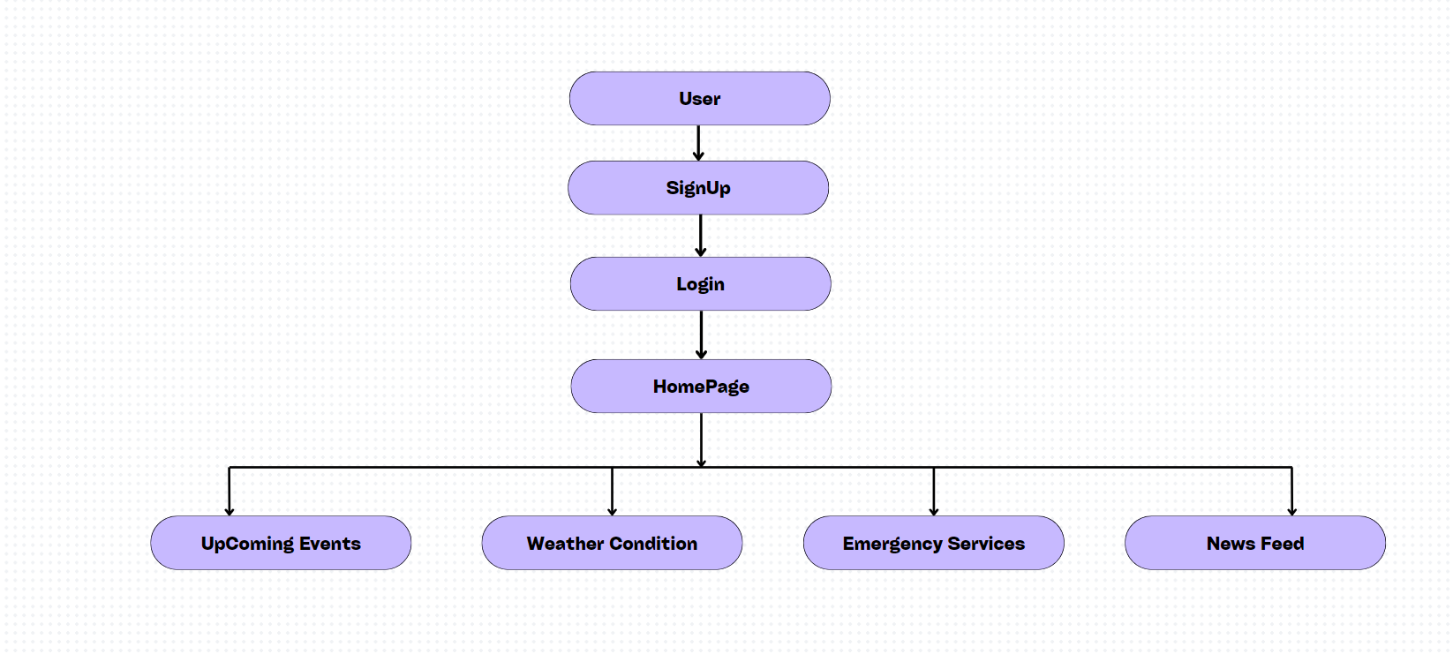

**System Block Diagram ( Fig.1 )**

The **Smart City Guide** is an interactive web application designed to enhance urban living by providing residents and tourists with real-time information and essential services. The user journey begins at the **Login/Signup** page, where users can create a new account or log in to access personalized features. Upon successful authentication, users are directed to the **Homepage**, which serves as the central hub of the application, displaying key functionalities. From the homepage, users can navigate to various sections, including **Upcoming Events**, where they can explore local activities and gatherings, and the **Weather Conditions** section, which provides real-time updates on the city's weather.Additionally, the application offers quick access to **Emergency Services**, such as hospitals ensuring users can find help when needed. Users can also stay informed with the **News Feed**, which features the latest updates and announcements relevant to the community

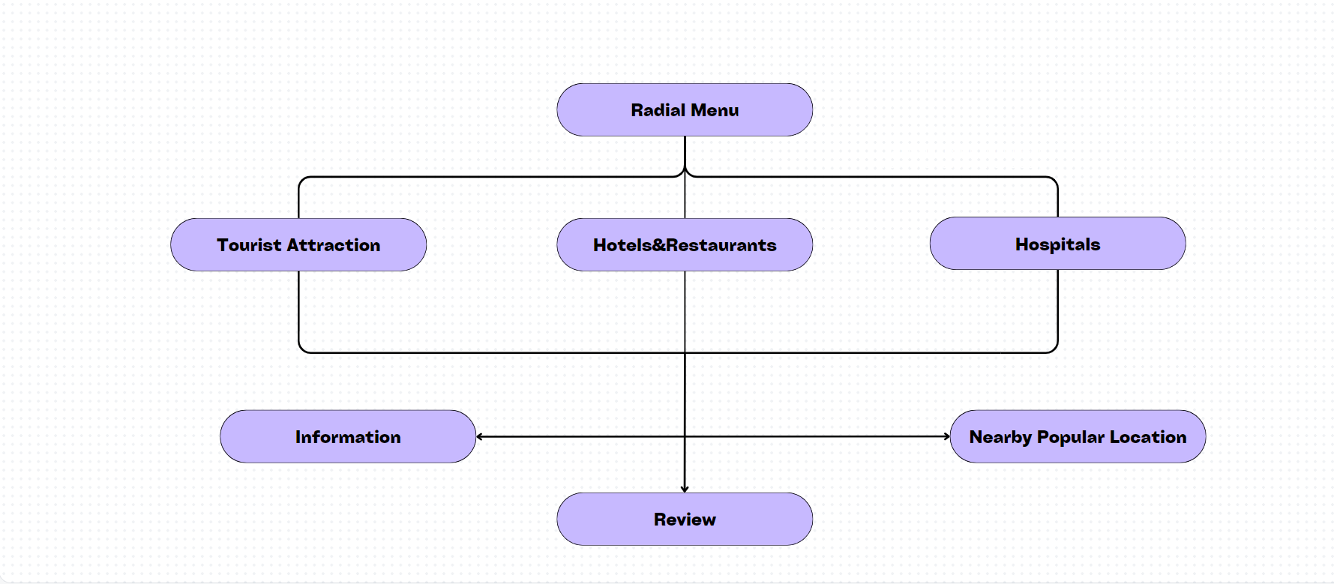

**Smart City Guide ( Fig.2 )**

It is a comprehensive web application designed to assist tourists and residents in discovering and navigating the city’s attractions, accommodations, dining options, and essential services. Users begin their journey on the homepage, where they can access different sections dedicated to **Tourist Attractions**, **Hotels**, **Restaurants**, and **Hospitals**. Each section provides detailed information, including descriptions, locations, operating hours, and contact details.Moreover, users can read and submit reviews for each establishment, fostering a community of shared experiences and recommendations

**Implementation**

**SIGNUP PAGE:**

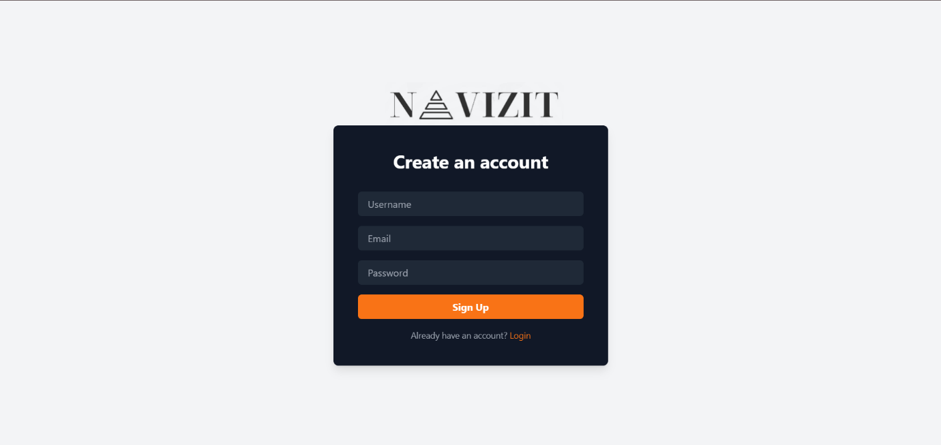

**Sign up page ( Fig.1** )

In this Page as shown in above Fig.1 user will be set username,email and password according to it, and press submit button then account is created in database of user. If the user has already have an account then pressing login will move to next page.

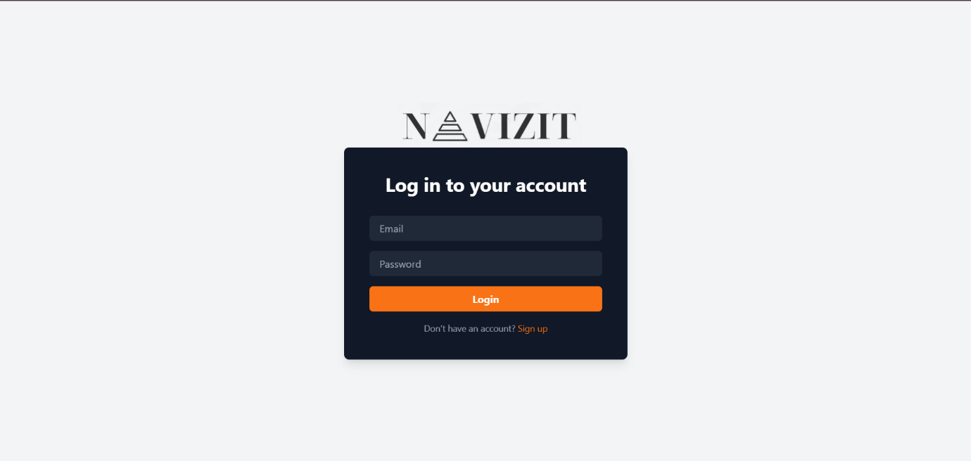

**Login page ( Fig.2 )**

In this login page as shown in Fig.5 where user have to enter the email and password set in previous page and then enter login button to moving next page.

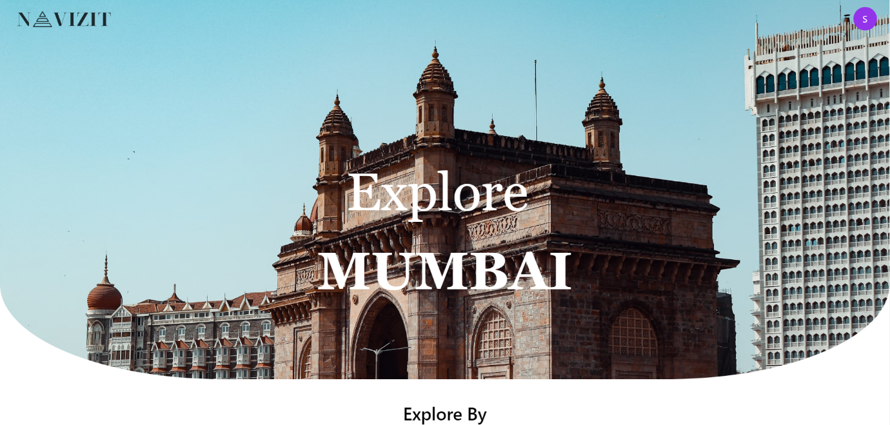

**Home page ( Fig.3)**

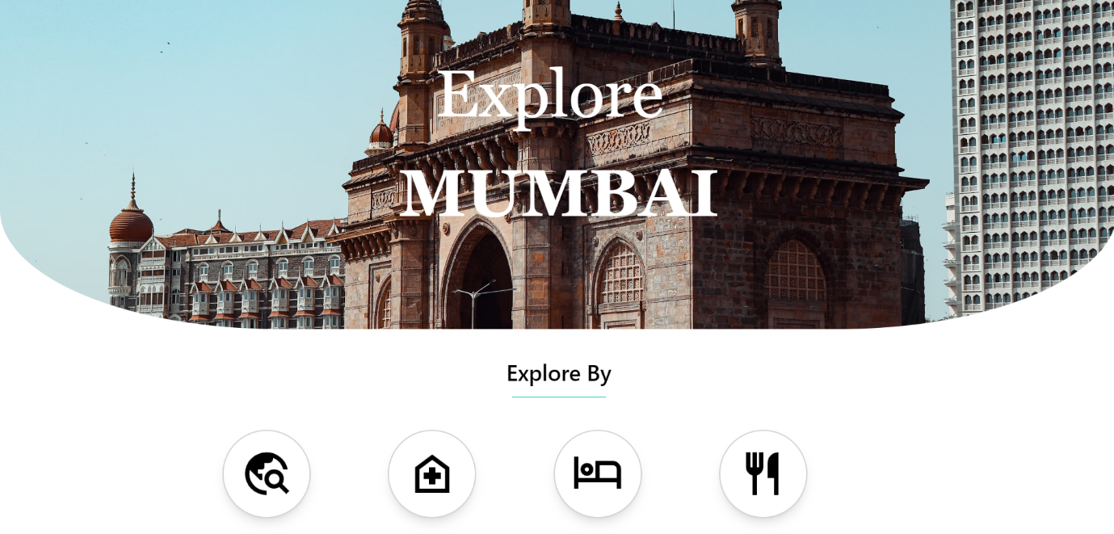

**Tourist places ( Fig.4 )**

As shown in Fig.4 this is a Home page including four section tourist places, hospitals,restaurant and hotels which gives information about particular places in Mumbai City.

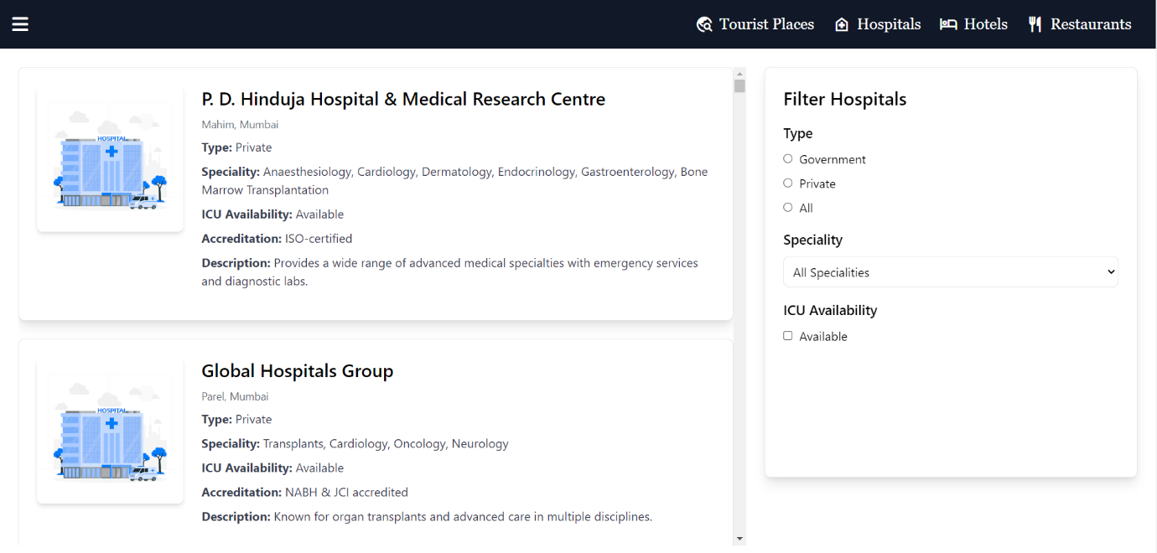

**Hospitals ( Fig.5 )**

As shown in Fig.8 this page indicates information about hospital by selecting hospital section. There are three radio buttons in hospital section they are government, private and all. When the user clicks on government all government hospitals are displayed likewise for private.

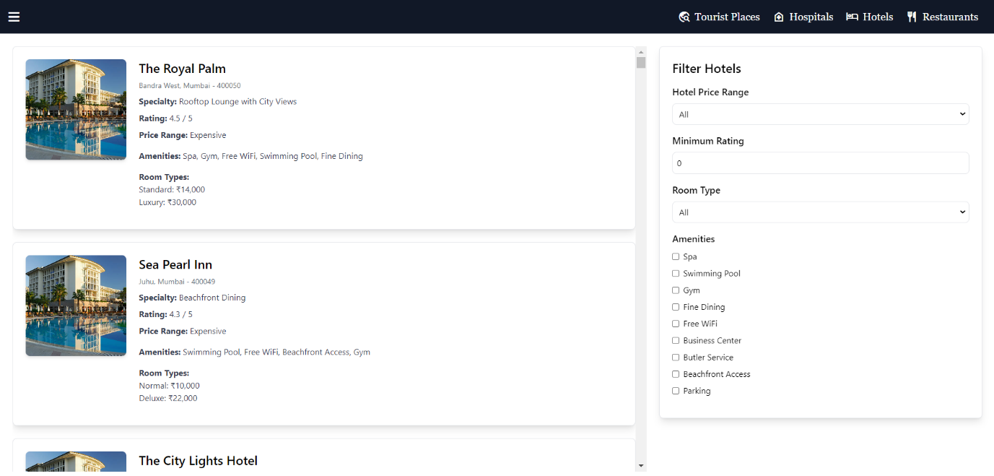

**Select Hotels ( Fig.6 )**

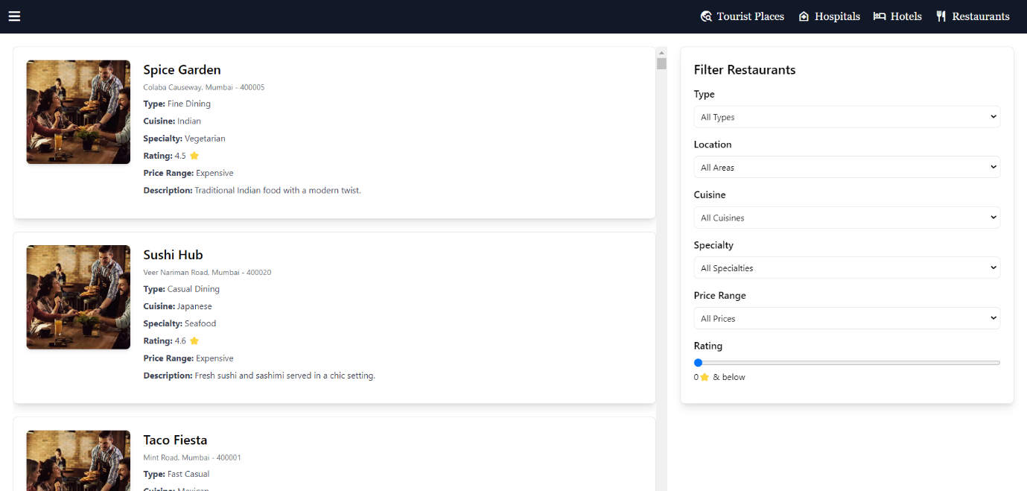

**Restaurants ( Fig.7 )**

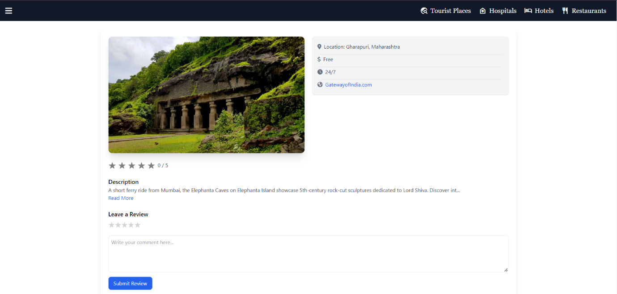

**Tourist Places ( Fig.8 )**

As shown in the Fig.8 there is review section in which user can write it’s experience after visiting that place.

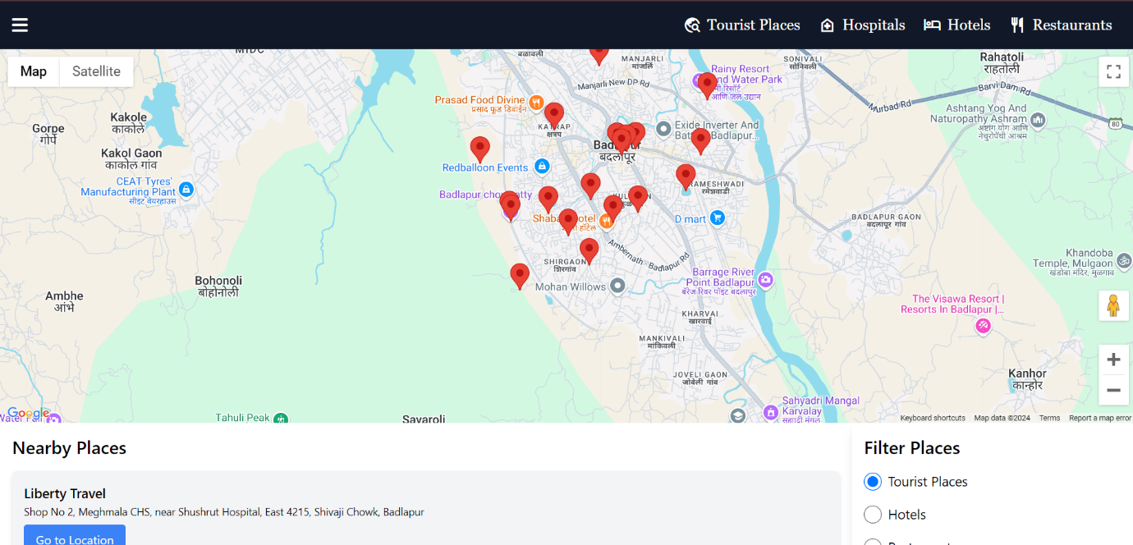

**Nearby Places Around You ( Fig.9 )**

As shown in the Fig.9 there is google map which shows nearby places around user.

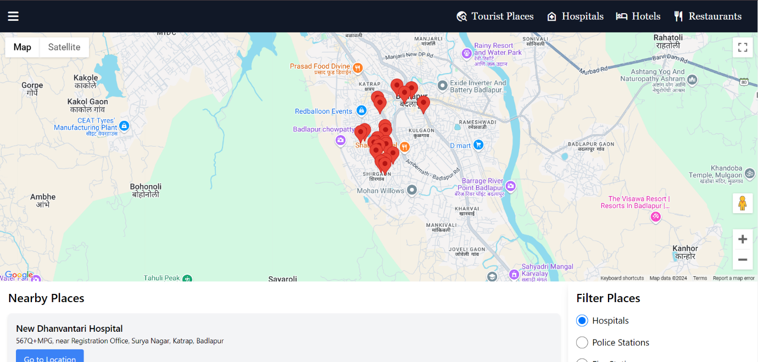

**Emergency Services ( Fig.9 )**

As shown in the Fig.9 there is google map which shows nearby emergency services based on user’s location.

**BACKEND:** We have made backend by using MONGODB and collecting the information of there review for each place.

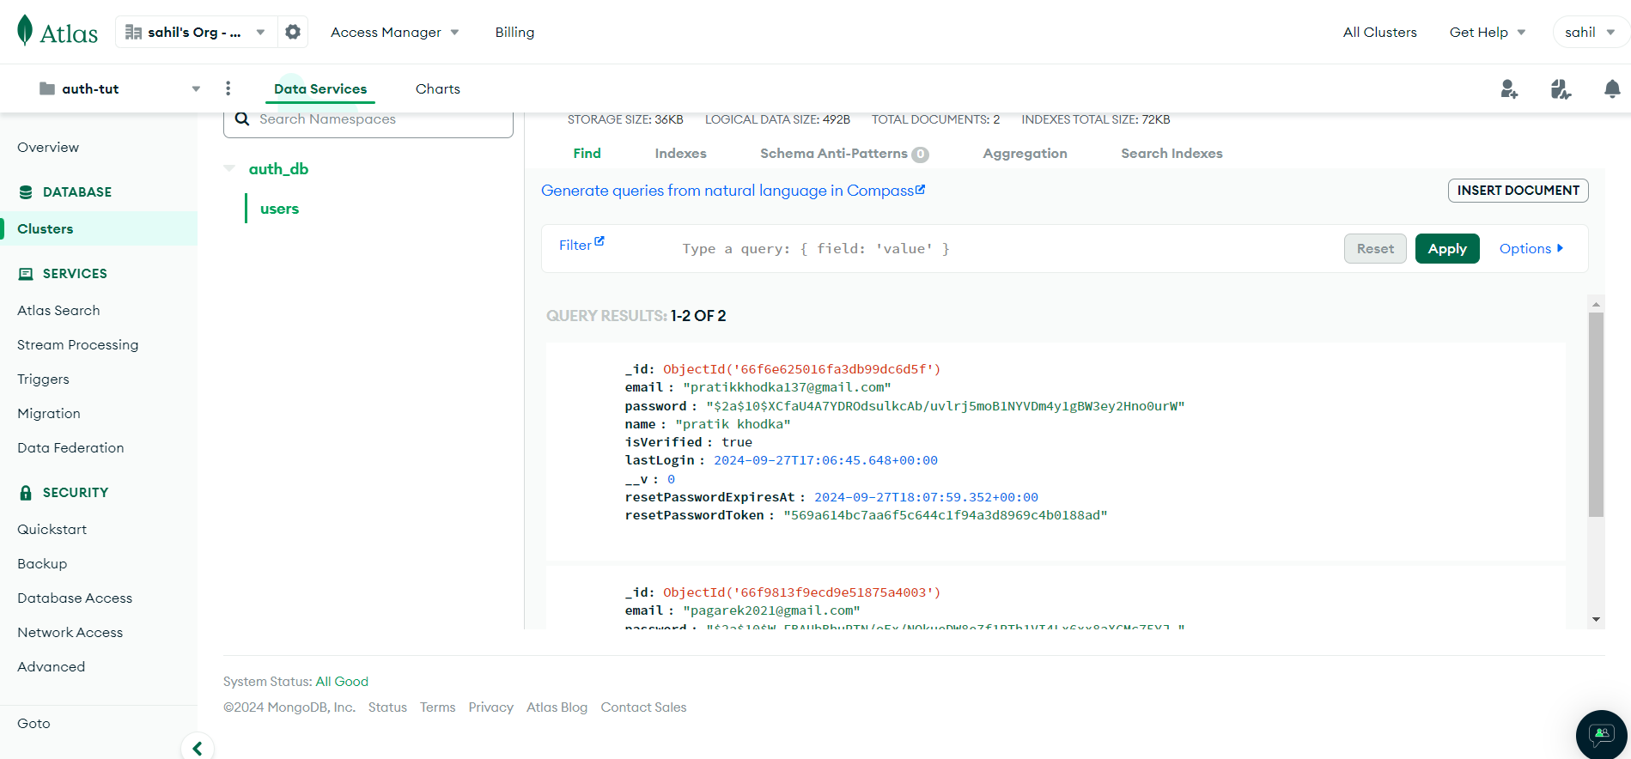

**Database of user details( Fig.10 )**

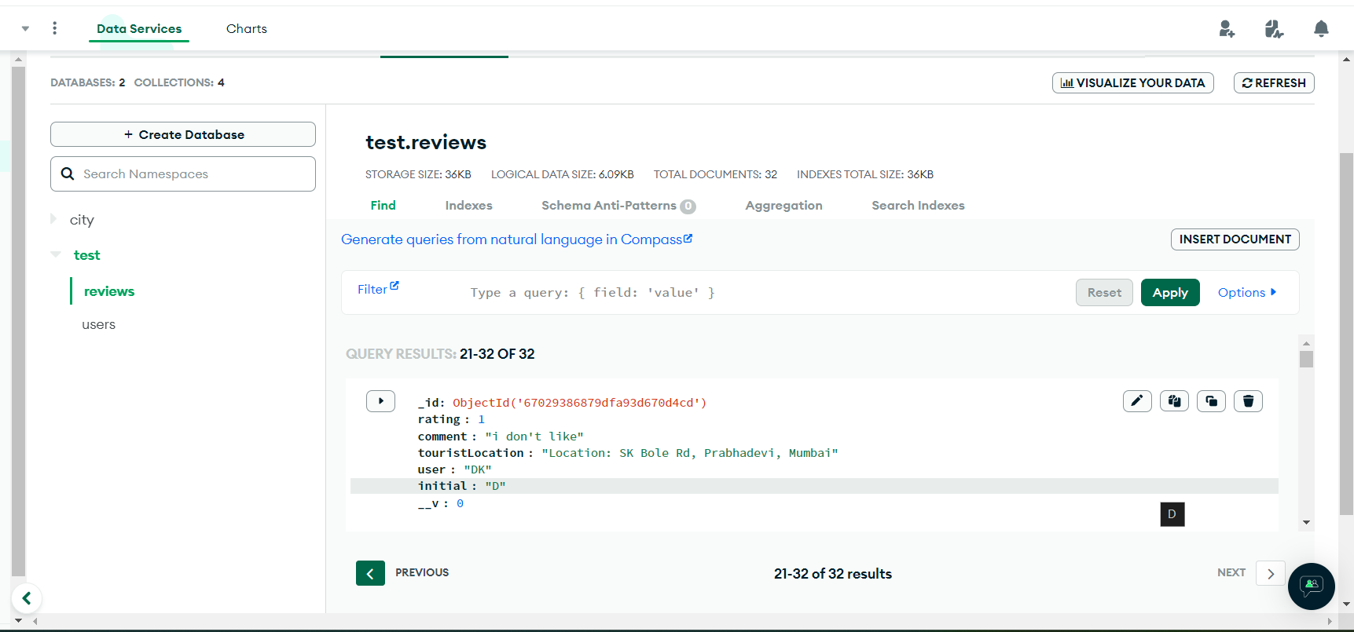

**Database of reviews and rating ( Fig.11)**

**Testing**

Testing an application to its smallest unit is called Unit Testing. Again, testing each module of an application which numerous test cases and checking validations against unforeseen scenarios is what unit testing is all about. Once a bug is detected, that is recorded in the bug tracker, a ticket is raised, this bug is fixed, and again new unit test cases are written to perform unit testing over the debugged piece of code.

|  |  |  |  |
| --- | --- | --- | --- |
| **Module** | **Test Case** | **Executed Result** | **Observed Result** |
| Tourist/Resident | User tries to Login | User does not exist | Failed Login |
| Tourist/Resident | Provides invalid username | User not found | Failed Login |
| Tourist/Resident | Provides wrong password | Username password does not exist | Failed Login |
| Tourist/Resident | Click on Login | Homepage Opens | Pass |
| Tourist/Resident | Enters OTP | Verified successfully | Pass |
| Tourist/Resident | Adding Reviews and Rating | Implemented Successfully | Pass |
| Tourist/Resident | Logout | Implemented Successfully | Pass |

**Tests performed on user module**

**CONCLUSION**

The Smart City Guide project for Mumbai helps users easily find information about attractions, hotels, and restaurants in the city. It improves the urban experience through real-time updates and community reviews, making city navigation simpler and more enjoyable.

**Future Scope**

* **ML Application:** This algorithm suggests places based on user behavior and preferences. For example, if a user frequently visits cultural places, it will recommend similar ones.
* **Engagement**: Create a platform for users to engage with each other, ask questions. This can help in building a strong community of users.
* **Personalized Recommendations:** Suggest nearby tourist attractions, restaurants, or events based on user preferences and location.
* **Multi-language Support**: Incorporate multi-language support to cater to a diverse group of tourists, especially those who may not be fluent in English.
* **Social Media Integration**: Allow users to share their experiences on social media directly from the app, encouraging user-generated content and increasing the app's visibility.
* **Crowd Prediction at Tourist Spots** :Predict crowd density at popular tourist places in Mumbai based on historical data.
* **Time Series Forecasting**: Use historical visitor data (if available) to predict crowd levels during certain times of the day or year.

**References**

[1] Cacho, A., Mendes-Filho, L., Estaregue, D., Moura, B., Cacho, N., Lopes, F., & Alves, C. (2016). Mobile tourist guide supporting a smart city initiative: a Brazilian case study. *International Journal of Tourism Cities*, *2*(2), 164-183.

[2] Kaur, M. J., & Maheshwari, P. (2016, October). Smart tourist for dubai city. In *2016 2nd international conference on next generation computing technologies (NGCT)* (pp. 30-34). IEEE.

[3] Chavan, R., Bhoir, M., Sapkale, G., & Mhatre, A. Smart Tourist Guide System. *Engpaper Journal*.